Stay up to date with COVID-19 @ https://healthywa.wa.gov.au/
Term 1 2020
Newsletter – Week 10
Thursday 26th March

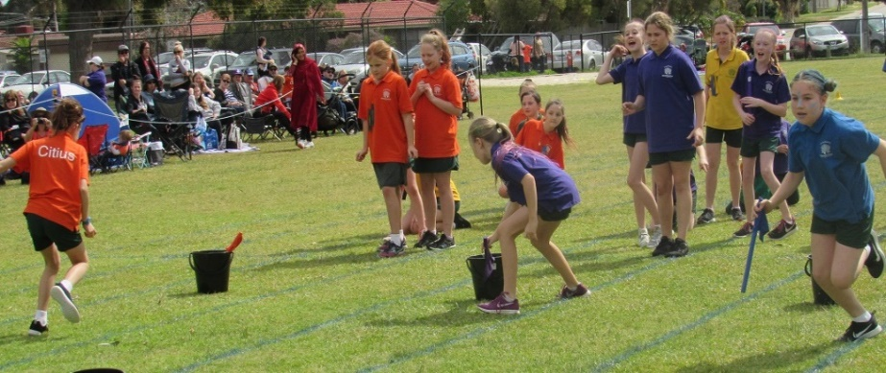
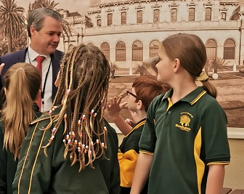
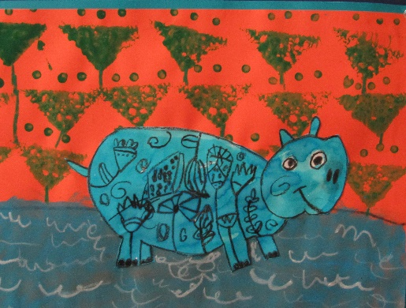
29 Solandra Way, FORRESTFIELD WA 6058 08 9483 2200
A 21ST CENTURY SCHOOL
From the Principal
What a term it has been! I wish to take this opportunity to thank numerous people for their support and assistance over the course of a challenging term one.

Firstly, the parents and carers of the Woodlupine Community. You have been fantastic. Under extremely different and difficult circumstances you have been a great source of support for our school.

I would also like to acknowledge the school staff. This is a very difficult time for them as well. Work conditions were changing daily. Increased demands for communication and sanitation taxed us all. The pressure involved in trying to learn how to support home schooling while looking after students and each other at school were intense.

Thanks also to Kathryn and Pam and their troops in the P&C and School Board. Their support and understanding of the situation and ability to find volunteers when our school needed them has been greatly appreciated by all, especially me as Principal. It is inspirational seeing our community pull together like this.

Book Fair
I would like to acknowledge and thank Judy Oyston and her team for the amazing job they did with the Book Fair. I’m pleased to be able to announce that, thanks to our extraordinarily supportive Woodlupine families, we sold over $1200 of books and stationery! What a great help this must have been for home schooling.

This means our school will receive 30% commission. In effect, we can now purchase over $350 worth of books and stationery for our library and home reading program. The raffle prize winners were drawn by Mrs Pescodd. Congratulations to Liam in year 5, Lachlan in year 2 and Lucas in Kindy.

Preparations
Staff are continuing to prepare, and develop materials, for home learning. The department has developed the Learning at home website to support online learning. Resources will continue to be added over the coming weeks.

Please let the school know ASAP if you need hard copies of packages. We will notify you next term when they are available for collection and advise how to return them for assessment.

Health
Remember Handwashing with soap and water is the BEST way to reduce the spread COVID19 – and other bugs. We can control what we watch, what we read, what we say and what we do. I ask that you continue to choose positivity and support for our school community.
Trevor Phoebe, Principal

