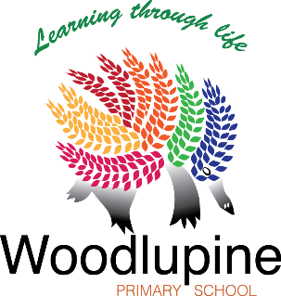
WOODLUPINE PRIMARY SCHOOL
Friday 7th Free Dress Day
Gold Coin Donation
Sport theme

Newsletter – Term 3 Week 2
AN INDEPENDENT PUBLIC SCHOOL

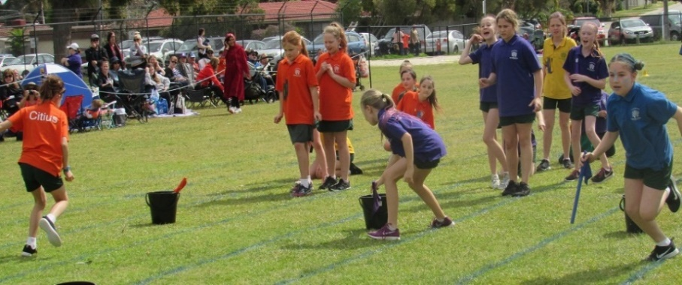
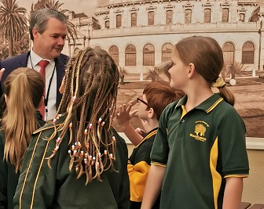
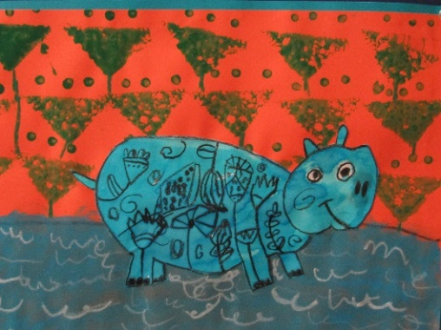
29 Solandra Way, FORRESTFIELD WA 6058 08 9483 2200
A 21ST CENTURY SCHOOL

From the Principal
Welcome back to term three, we hope that we see more of our parent group this term once restrictions ease a little further. However, we still need parents to drop students off outside the blocks. Over the course of last term, when parents were not permitted to enter school grounds, teachers reported two main benefits:
- Students were quicker to settle in the mornings; and
- Teachers were able to commence educational activities, with the class as a whole, a little earlier.

Our school board has endorsed this approach as it supports improved student learning and sound hygiene practice. Parents are very welcome to come into classrooms at the end of the day once the students have left. There will be an assembly on Friday 7th August. Year two students will present an item and the cross country medals will be presented. Parents of year two students, cross country medallists, P&C and board members are invited to attend.

FREE DRESS DAY – GOLD COIN DONATION
One of our students was injured by a car recently and is still in hospital. Our student leaders are raising funds for a care package for this student. All students are encouraged to come in free dress on Friday 7th Aug. The theme is Sport.

ATHLETICS CARNIVAL
Our annual athletics carnival will be held on Friday 4th September. At this stage it is unclear what the rules will be regarding parent attendance. The 200m and 400m events will be held on Wednesday 2nd September.

FROM THE P&C
Our amazing P&C met last week and discussed a range of activities. Their volunteers will run a Father’s Day stall later this term and a sausage sizzle at the athletics carnival in September. Please support them if you can.

FROM THE BOARD
Our board met and discussed a range of items including our improved attendance figures, science at our school, staffing procedures and guidelines for our school as an Independent Public School and assemblies moving forward. After a period of review, our board has endorsed our Risk Management and Health policies. Our board is currently reviewing our Digital Technologies policy.

If you would like to find out more, or have a say in school policy, please see one of our board members. Stay Safe and Healthy.

Trevor Phoebe

Principal

U6,7,8,9,10,11,12,13,14,15,16,18
Girls U14 and U17
New Players Welcome
Contact: Barry Jordan 0417 184928
Email: kalabulls.juniors@gmail.com
Facebook: Kalamunda Rugby Union Juniors

